Final Individual CTEC 298 Paper

Saiquan Jamison

CTEC 298-101

1. Introduction
2. Summary of CTEC Paper
3. Description of CTEC material submitted
4. Description of the plot deliverables
5. Summary/conclusion
6. References

**I. Introduction**

This paper covers several of the topics that were discussed in my CTEC 128 class in which my project from that class was about the Rental Housing Market and what went into the process of me writing my individual paper. The materials from the class includes a group powerpoint, a final individual research paper, and the different data files that were used throughout the research process. The paper will also include several different topics that were discussed in this CTEC 298 class, which included Jupyter Notebook, Github, Matplotlib, and Pandas.

**II. Summary of CTEC 128 Paper**

My paper was a Research Paper on the topic of the Rental Housing Market and as a group we focused on Family income, business properties, demographics, age groups, race, prices, current economical cot, inflation history of rental property costs, location( states in the USA. The research problem here was to determine what are the influencing factors the local housing markets such; why the number of rental properties is growing by the day as opposed to house ownership growth. The main goal of the paper was to provide an accurate analysis in a report form, local housing market trends to the U.S Department of Housing and Urban Development’s Office of Housing Support. Some questions that were put into effect during the process of me doing my research were;v

* Are the locations in rural or urban areas
* How has inflation affected the housing market?
* For demographics, I’ll consider age groups?
* How has the rental market affected people with disabilities?
* What type of family income can afford certain types of rental properties (good, bad rental properties)?
* How has the housing market affected business rental properties such as Hotels, restaurants, small and large offices?

**II. Description of CTEC material submitted**

This Material I submitted consisted of a Concept Map that me and my group came up with which basically helps us all out throughout the entire process of our research and also our own individual papers. The concept map was used as a learning and teaching technique, which helped us break down our ideas, helped me brainstorm the different ideas that we were focusing on. Also helped me to gain an enhanced knowledge of the topics and evaluate the information. I also submitted the different Data Files that we were either assigned or research on our own during our initial research process. One of the Documents were an Excel File which was our Codebook that describes the contents, structure, and layout of our data collection. The other Excel file included all of the states, city, region and months and years that we were researching, each Region was broken down into its own small excel slide and showed averages of rental prices throughout the region by year. I also submitted my group presentation which we broke down by region and everyone had their own region to research and with the powerpoint we all brought our individual region together to form our one group powerpoint. The region that I was assigned was the Southwest Region which included the states of Oklahoma, Arizona, New Mexico, and Texas which was one of the highest of the states in all regions. Concluding our powerpoint we came up with recommendations and thoughts that would help the rental market, which included better incentives for first time home buyers, consider improving the educational systems, and reducing the cost of higher education, these play a factor in some families buying houses some may have to try to worry about getting their children or themselves through school which has its own large sum of money. That would prevent someone from having the ability to become a home buyer.

**IV. Description of the plot deliverables**

The 6 different plots that we used were scatter plots, bar graphs, histograms, pie plot/chart, stack/area plot, and multiplot graph. The scatter plot compares two or more variables, changes over time for two or more groups. The bar graph is used to compare data between groups and measure changed over time, use categorical variables. The histogram is used to represent data given in the form of some groups, a display of statistical information that uses rectangles to show the frequency of data item in successive numerical intervals of equal size. The pie plot is used to measure a certain point in time, categorical data, also when dealing with percentages. The stack/area plot tracks changes over time, groups of data. A stack plot is a plot that shows the whole data set with easy visualization of how each part makes up the whole. A Multiplot graph shows subplots for two or more sets of data.

STACKED BAR GRAPH

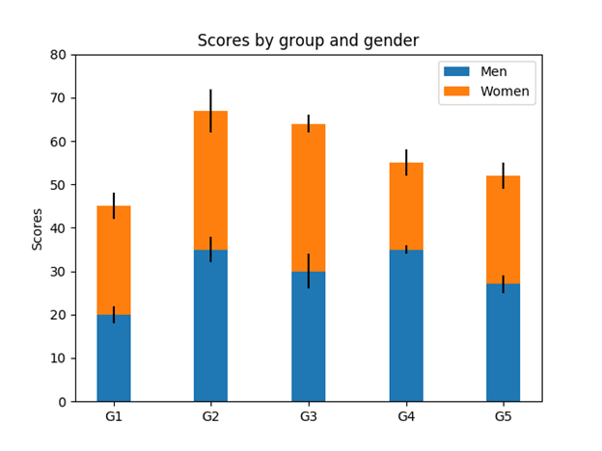

CODE:

import numpy as np

import matplotlib.pyplot as plt

N = 5

menMeans = (20, 35, 30, 35, 27)

womenMeans = (25, 32, 34, 20, 25)

menStd = (2, 3, 4, 1, 2)

womenStd = (3, 5, 2, 3, 3)

ind = np.arange(N) # the x locations for the groups

width = 0.35 # the width of the bars: can also be len(x) sequence

p1 = plt.bar(ind, menMeans, width, yerr=menStd)

p2 = plt.bar(ind, womenMeans, width,

bottom=menMeans, yerr=womenStd)

plt.ylabel('Scores')

plt.title('Scores by group and gender')

plt.xticks(ind, ('G1', 'G2', 'G3', 'G4', 'G5'))

plt.yticks(np.arange(0, 81, 10))

plt.legend((p1[0], p2[0]), ('Men', 'Women'))

plt.show()

BAR GRAPH

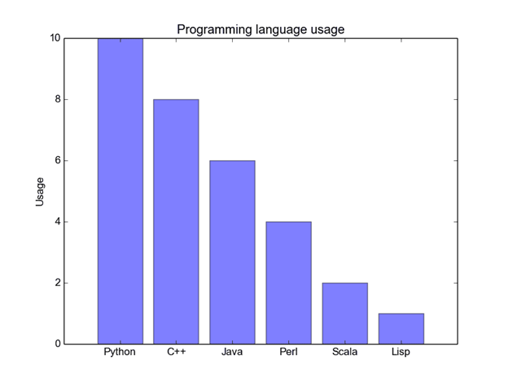

CODE:

import matplotlib.pyplot as plt; plt.rcdefaults()

import numpy as np

import matplotlib.pyplot as plt

objects = ('Python', 'C++', 'Java', 'Perl', 'Scala', 'Lisp')

y_pos = np.arange(len(objects))

performance = [10,8,6,4,2,1]

plt.bar(y_pos, performance, align='center', alpha=0.5)

plt.xticks(y_pos, objects)

plt.ylabel('Usage')

plt.title('Programming language usage')

plt.show()

HISTOGRAM

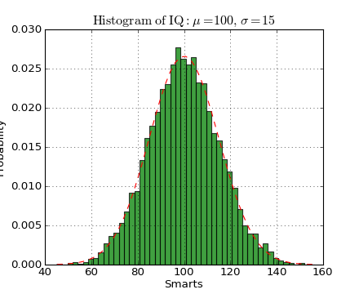

import numpy as np

import matplotlib.mlab as mlab

import matplotlib.pyplot as plt

mu, sigma = 100, 15

x = mu + sigma*np.random.randn(10000)

n, bins, patches = plt.hist(x, 50, normed=1, facecolor='green', alpha=0.75)

y = mlab.normpdf( bins, mu, sigma)

l = plt.plot(bins, y, 'r--', linewidth=1)

plt.xlabel('Smarts')

plt.ylabel('Probability')

plt.title(r'$\mathrm{Histogram\ of\ IQ:}\ \mu=100,\ \sigma=15$')

plt.axis([40, 160, 0, 0.03])

plt.grid(True)

plt.show()

SCATTER PLOT

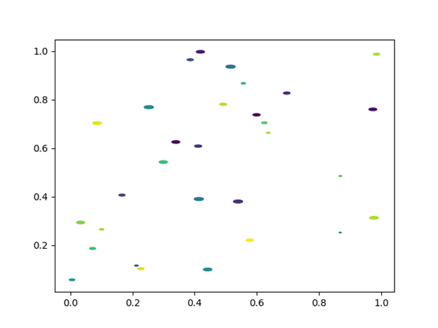

import matplotlib.pyplot as plt

import numpy as np

rx, ry = 3., 1.

area = rx * ry * np.pi

theta = np.arange(0, 2 * np.pi + 0.01, 0.1)

verts = np.column_stack([rx / area * np.cos(theta), ry / area * np.sin(theta)])

x, y, s, c = np.random.rand(4, 30)

s *= 10**2.

fig, ax = plt.subplots()

ax.scatter(x, y, s, c, marker=verts)

plt.show()

PIE CHART

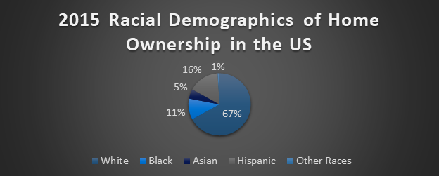

import matplotlib.pyplot as plt

labels = 'White', 'Black', 'Asian', 'Hispanic', ‘Other Races’

sizes = [1, 16, 5, 11, 67]

explode = (0, 0, 0, 0)

fig1, ax1 = plt.subplots()

ax1.pie(sizes, explode=explode, labels=labels, autopct='%1.1f%%',

shadow=True, startangle=90)

ax1.axis('equal')

plt.show()

MULTIPLOT

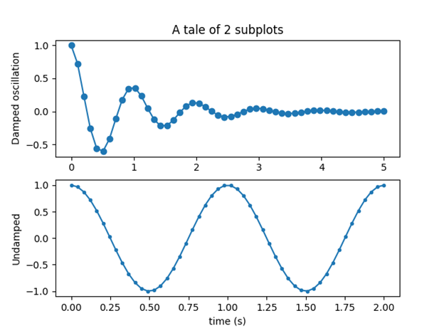

import numpy as np

import matplotlib.pyplot as plt

x1 = np.linspace(0.0, 5.0)

x2 = np.linspace(0.0, 2.0)

y1 = np.cos(2 * np.pi * x1) * np.exp(-x1)

y2 = np.cos(2 * np.pi * x2)

plt.subplot(2, 1, 1)

plt.plot(x1, y1, 'o-')

plt.title('A tale of 2 subplots')

plt.ylabel('Damped oscillation')

plt.subplot(2, 1, 2)

plt.plot(x2, y2, '.-')

plt.xlabel('time (s)')

plt.ylabel('Undamped')

plt.show()

V. Summary/conclusion

The many different data visualizations through pythons were very informative this entire class and showed different ways that i would be able to better use the data that I am given and translate it in many different ways using different kinds of plots and charts. All of the different tutorials helped throughout the process and gave me a better understanding of how python coding worked because this was the first time that I took a class that involved any kind of python coding, early on it was difficult but once things got rolling I got the chance to get the hang of things.

**VI. References**

<https://www.youtube.com/watch?v=yZTBMMdPOww>

https://www.datacamp.com/community/tutorials/matplotlib-tutorial- python?utm_source=adwords_ppc&utm_campaignid=1565261270&utm_adgroupid=67750485268&ut m_device=c&utm_keyword=&utm_matchtype=b&utm_network=g&utm_adpostion=1o1&utm_creative =332661264374&utm_targetid=aud-392016246653:dsa- 473406587955&utm_loc_interest_ms=&utm_loc_physical_ms=9007722&gclid=EAIaIQobChMInu_KytXY 5AIVhbHtCh3nxQnHEAMYASAAEgJJP_D_BwE

http://www.marmakoide.org/download/teaching/dm/dm-matplotlib.pdf

[**h**](https://www.youtube.com/watch?v=-0NwrcZOKhQ)[**https://matplotlib.org/**](https://matplotlib.org/)

[**ttps://www.youtube.com/watch?v=-0NwrcZOKhQ**](https://www.youtube.com/watch?v=-0NwrcZOKhQ)

[**https://www.dataquest.io/**](https://www.dataquest.io/)